### passport foto Lee Piccinini

#### ITALY: 61 CASETTE DI PIANOCERRO ASCOLI PICENO ITALY 63100

#### SCOTLAND: 89 G WALKER ROAD TORRY ABERDEEN AB 11 8DJ

Home: **(+39) 0736 898577 (+44)** 07891336904

Cell.: (**+39) 338 8611582 A RESPONSE ALWAYS:**

Email:[***lindopiccinini@yahoo.com***](mailto:lindopiccinini@yahoo.com)

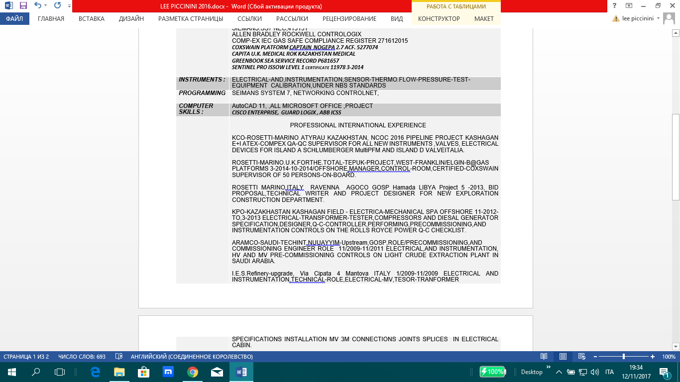Nationality: USA-EUROPEAN

LanguagesFLUENT -in English-Italian, BASIC -in Arab,Spanish,French

*1986/ F.C.C. FEDERAL COMMUNICATIONS COMMISSION U.S.A. License; N.3.F.R.T*

*Licenced CRO-Tech ship.to shore radio-telegraph-telecom special systems services.*

*1988-1989: AT&T U.S.A Special Services Certificate.*

*1983-1988: Capitol College of George Washington University, U.S.A.*

*(***Bachelor of Science –BSEE)** *in Engineering Electrical and Electronics.*

*(***American Society For Engineering Education –ASEE)**

|  |  |
| --- | --- |
| ***SPECIALIST IN:*** | ELECTRICAL,+ INSTRUMENTATION - IN OIL/GAS, FIELD REFINERY-UPSTREAM–OFFSHORE-LNG INSTALLATION  STEEL MANUFACTURING AUTOMATION,CHEMICAL PLANT PROCESSING BATCHING NUCLEAR-POWER INSTALLATIONS , MILITARY BASE INSTALLATIONS,  AUTOMATION SYSTEMS CONTROLS AND ROBOTICS |
| ***CERTIFICATION:***  ***SAFETY:***  ***PROTOCOLS:*** | ARAMCO Q/C SPECIALIST:OLYAN DESCON S.A.141.2008  BOSIET OFFSHORE 00295700190314146451 /14  NEBOSH INTERNATIONAL ATM OSHA 343431  CA-EBS 98475902190814401  PETROFAC PTLAC 4700039624  OPITO MIST 1466504 HELICOPTER CHC VANTAGE  3M-IEEE-UL CERTIFICATE MV-HV  SIEMANS:SS7 NEC,413151  ALLEN BRADLEY ROCKWELL CONTROLOGIX  COMPEX IEC GAS SAFE COMPLIANCE REGISTER 271612015  ***COXSWAIN PLATFORM CAPTAIN NOGEPA 2.7 ACF. 5277074***  ***CAPITA U.K. MEDICAL + ROK KAZAKHSTAN MEDICAL***  ***GREENBOOK SEA SERVICE RECORD P681657***  ***SENTINEL PRO ISSOW LEVEL 1 certificate 11978 3-2014*** |
| ***INSTRUMENTS :*** | ELECTRICAL-AND,INSTRUMENTATION,SENSOR-THERMO.FLOW-PRESSURE-TEST-EQUIPMENT CALIBRATION,UNDER NBS STANDARDS |
| ***PROGRAMMING*** | SEIMANS SYSTEM 7, NETWORKING CONTROLNET, |
| ***COMPUTER SKILLS :*** | AutoCAD 11, ,ALL MICROSOFT OFFICE ,PROJECT  ***CISCO ENTERPRISE, GUARD LOGIX , ABB ICSS*** |
|  | PROFESSIONAL INTERNATIONAL EXPERIENCE  MAIRE TECNIMOUNT TEMPA ROSSA PROJECT TOTAL E&P CORLETO PERTICARA BASCILICATA ITALY ELECTRICAL-MECHANICAL COMPLETIONS PRE-COMMISSIONING  MARCH 2017 –DEC 2017    KCO-ROSETTI-MARINO ATYRAU KAZAKHSTAN, NCOC 2016 PIPELINE PROJECT KASHAGAN E+I ATEX-COMPEX QA-QC SUPERVISOR FOR ALL INSTRUMENTS & VALVES, ISLAND A SCHLUMBERGER MULTIPHASE FLOW METER AND ISLAND D ALL VALVEITALIA.SPECIAL DEVICES  ROSETTI-MARINO.U.K.FORTHE.TOTAL-TEPUK-PROJECT,WEST-FRANKLIN/ELGIN-B@GAS PLATFORMS 3-2014-10-2014/OFFSHORE,MANAGER,CONTROL-ROOM,CERTIFIED-COXSWAIN SUPERVISOR OF 50 PERSONS-ON-BOARD.  ROSETTI MARINO,ITALY RAVENNA AGOCO GOSP Hamada LIBYA Project 5 -2013, BID PROPOSAL,TECHNICAL WRITER AND PROJECT DESIGNER FOR NEW EXPLORATION CONSTRUCTION DEPARTMENT.  KPO-KAZAKHASTAN KASHAGAN FIELD - ELECTRICA-MECHANICAL SPA OFFSHORE 11-2012-TO,3-2013 ELECTRICAL-TRANSFORMER-TESTER,COMPRESSORS AND DIESAL GENERATOR SPECIFICATION,DESIGNER,Q-C-CONTROLLER,PERFORMING,PRECOMMISSIONING,AND INSTRUMENTATION CONTROLS ON THE ROLLS ROYCE POWER Q-C CHECKLIST.  ARAMCO-SAUDI-TECHINT,NUUAYYIM-Upstream,GOSP,ROLE/PRECOMMISSIONING,AND COMMISSIONING ENGINEER ROLE 11/2009-11/2011 ELECTRICAL,AND INSTRUMENTATION, HV AND MV PRE-COMMISSIONING CONTROLS ON LIGHT CRUDE EXTRACTION PLANT IN SAUDI ARABIA.  I.E.S.Refinery-upgrade, Via Cipata 4 Mantova ITALY 1/2009-11/2009 ELECTRICAL AND INSTRUMENTATION,TECHNICAL-ROLE,ELECTRICAL-MV,TESOR-TRANFORMER SPECIFICATIONS INSTALLATION MV 3M CONNECTIONS JOINTS SPLICES IN ELECTRICAL CABIN.    OTHER INTERNATIONAL EXPERIENCE  ARCELOR-STEEL-MILL,Fos-Sur-Mer,France(REVAMPING-PROJECT)2/2008-12/2008 ELECTRICAL SUPERINTENDANT ENGINEER ALL PHASES OF PROJECT.WROTE IN MS PROJECT ALL DIRECTION OF PROJECT, PERFORMED AS SUPERINDENDANT IN FIELD.CONTROL ROOM SPECIFICATIONS SUPERVISOR SEIMANS SS7 INSTALLATION.  KNAUF GERMAN-INDUSTRY , Podere Paradiso Castellina Marittima,Toscana 3 M. SHEETROCK UPGRADE AND REVAMPING PROJECT TECHNICAL SUPERVISOR DANFOSS FREQUENCY CONVERTOR TO SS7 PLC WITH ALL PHASES OF NEW INSTALLATION 6 MONTHS 2007  MODITECH, LNG/Gas-API PROJECT Via del Lavoro 54, 20040 Busnago, Milano 30G. INSTRUMENTATION, COMPRESSOR AND INSTALLATION COORDINATOR FOR GAS TURBINE.  PROCLESIS,-PFIZER Power Via Emilia 18, 20790 Segrate, Milano PFIZER PHARMA WITH CISCO INSTALLATION AND REMOTE ACCESS COORDINATOR ATT FIBER DSU-CSU MUX-TO CISCO    CAIA HARDWARE and SOFTWARE, Via Mameli 34, SBT, 11/2005-6/2006 TEAM LEADER FOR TEAM SYSTEMS INSTALLATIONS.BARILLA PASTA FOXBORO LCS IN MANUFACTURING UPGRADE PROJECT.  ELETTROMECCANICA ADRIATICA, Marina del Tronto, 3/2004-9/2005 ANGOLA TURBINE PROJECT TECHNICAL INSTRUMENTATION PANEL CONTROL AND INSTALLATION.  AMERICAN EXPERIENCE  E. E. SYSTEMS INC. Fork - Maryland, PROPRIETOR U.S.A Automation Systems TECHNICIAN with PERDUE FARMS SALISBURY MARYLAND , PLC CONFIGURATION AT GM BROENING HIGHWAY, EASTERN STAINLESS STEEL,ELECTRICAL ENGINEER ON REVAMPING PROJECT KENNECOTT COPPER REFINERY FLOW METER INSTRUMENTATION LIGHTING 1996-2000    BETHLEHEM Steel Corporation-Sparrows Point Baltimore, U.S.A PLC SYSTEMS TECHNICIAN MILITARY GRADE STEEL SIDE 1995-1996  AT&T TELECOMMUNICATIONS CORP. White Plains –New York, U.S.A .LONG LINES FIBER INSTALLATION , CENTRAL OFFICE RECONFIGURATION BELL OF PA,  FED-GSA SPECIAL SERVICES ON DIGITIZATION PROJECT 1989-1994  SCM Chemicals/GliddenPaints Essex-Maryland, U.S.A UPGRADE PROJECT INSTRUMENTATION PROCESS TECHNICIAN FOXBORO PAC LBC FOR TICL PLANT HYDROCLORIC AND SULFURIC SIDE. 1988-1989  EIL INSTRUMENTS SPARKS MARYLAND INSTRUMENTATION, TEST EQUIPMENT METERS,ANALOG AND DIGITAL CALIBRATION FOR MILITARY SPECIFICATION AND QC- ARMY-NAVY AND DOD DEFENSE COMPANYS 1986-88  EMC CONTROLS SPARKS Maryland-,ALASKAN PIPELINE PROJECT INSTRUMENTATION TECHNICIAN,INSTALLING-DC-POWER,SYSTEMSUPS-INSTALLATION.ARCTIC/WIRING CONFIGURATION 1984-85  GENERAL INSTRUMENTS-AMERICAN TOTALISATOR, S.A SUNCITYLEVEL1SYSTEMS TECHNICIAN FOR RACETRACK PROJECT USING VARIAN 77B CARD CONFIGURATION AND INSTALLATION 1983-84  DEPARTMENT OF NAVY – U.S. Marine Corp, Washington DC-2.5 YEARS E3 LANCE CORPORAL E4 ET CALIBRATION TECHNICIAN DD214 RE3E RE-ENLISTED RESERVE. |
|  |  |

# 

# I HAVE EXTENSIVE INTERNATIONAL TRAVEL EXPERIENCE, ANY COMPANY CAN EASILY DISPATCH MY SERVICES TO ANY LOCATION AND IN A REASONABLE AMOUNT OF TIME, FIND THE PROPER SOLUTION.

REFERENCES ARE:

LUIGI STRACCIA RE AUTOMATED ENGINEER LUIGISTRACCIA@GMAIL.COM ITALY 00393496916900

ABID HUSSAIN COMMISSIONING ENGINEERING MANAGER ABIDZZ@YAHOO.COM UK.004401745376788

HUBERT ROSSANO CAMPAIGN MANAGER TOTAL [HUBERT.ROSSANO@TOTAL.COM](mailto:HUBERT.ROSSANO@TOTAL.COM) FR 004401224233869