7 Hurworth Avenue | Mobile: | +44 (0) 7955602114 | KEVIN  TAYLOR
South Shields | Email: | kevintnigel@gmail.com
Tyne and Wear | Date of Birth: | 10/02/1983
NE34 7HG  England | Nationality: | British

Career Summary

Over 7 years’ experience in Oil and gas projects worldwide. Contractor/Subcontractor to Major operators.
Onshore and Offshore projects working with UK, Norwegian, European, Australian and American Directives.

- Delivered ATEX scope of first UK Compliant FPSO Completed (EPC) in China 2016 by implementing international working practises, ATEX Directive compliance, Full compliance with procurement documentation and Compiled ATEX Hazardous area Verification document to handover to IVB and UK HSE for Audit.
- Full ATEX compliance achieved with Glen Lyon FPSO with 32,000 Full detailed inspections carried out during Construction stage of project.

Scope of Onshore & Offshore Experience

Platforms- BP Clair Ridge, Forties Alpha Satellite, BP Andrew, Centrica Rough B, Centrica Rough A
FPSO- Glen Lyon, Citade De Saquarema, Western Isles.
Onshore Gas/oil Processing- Centrica storage Barrow In Furness, AGIP D Island Kazakhstan
Drill Ships- Transocean Deepwater Millennium, Transocean Deepwater Expedition
Power Generation- EON Ratcliffe on Soar, EON Isle of Grain CCGT
Locations Worked

UK, China, Brazil, South Korea, Singapore, Australia, Dubai, Kuwait and Kazakhstan.

Professional Qualifications & Related Training Courses

- 17th Edition IEE Wiring Regulations (C&G 2380)
- NVQ level 3
- C&G 235 part 1
- C&G 235 part 2
- C&G 236 part 2
- AM2 Practical
- Completed Electrical Apprenticeship
- Compex Hazardous Areas EX01, EX02, Ex03, Ex04
- Pan European BOSIET Offshore Safety OPITO, OLF, NOGEPA
- UKOOA/ Offshore medical
- Minimum industry safety training (MIST)
- Brazilian NR10 Electrical Safety at work
- Brazilian NR35 Working at heights
- SBM Citade De Saquarema Isolating authority
- ISSOW level 2 BP
- Currently studying towards a HNC in electronic/electrical engineering - Teesside Open University 60 credits gained

EMPLOYMENT HISTORY

May 2016- Present

Location- COSCO Shipyard, Qidong, China | 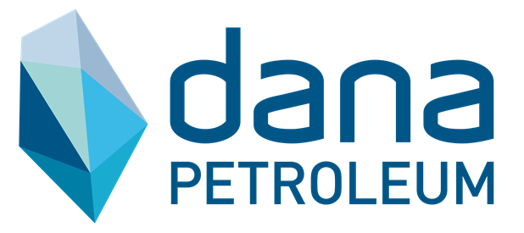
Project- Western Isles FPSO
Employer- Dana Petroleum

Lead QC ATEX CO-Coordinator/Focal Point

Reported Directly to FPSO Quality Manager- First UK Compliant FPSO to be completed (EPC) in China.

Started project 8 months before sail away, COSCO had control of all ATEX scope but audits from IVB were showing signs of potential compliance issues. I was tasked with taking over full scope of project and ensuring compliance.

Key Achievements/Main Duties:
- Responsible for the coordination of the site ATEX activities – Chair Meetings and ensure Company & Contractor interfaces with DNVGL acting as the Verification, Classification Assurance Body.
- Identified Project ATEX supporting evidence to demonstrate compliance with the Verification Safety Critical Elements & Performance Standards.
- Responsible for Final handover and completion of QC and ATEX scope of project
- Designed Inspection Test Report for Non Electrical ATEX to EN-13463
- Produced ATEX Hazardous Area Verification Documentation to comply with IEC 60079
- Supervised Local and regional inspectors, providing technical advice and guidance
- Produced procedures and Implementation plans to control methods and requirements by EPC, QC operatives and ATEX Inspectors
- Completed Non Electrical ATEX scope on FPSO to EN-13463 and compiled a Non Electrical Compliance Dossier
- Expedited and Controlled Electrical and Non Electrical ATEX registers for population and content
- Responsible for all mechanical completion A ITR’s for Electrical, Instrumentation, Telecom and ATEX
- Reviewing all vendor documentation within procurement stage of project
- Witnessing Inspection and attending tri-party walk downs
- Expedited Missing documentation from vendors to comply with IEC 60079 and EN-13463

February 2016- June 2016

Location- Maua Shipyard, Rio De Janeiro, Brazil | 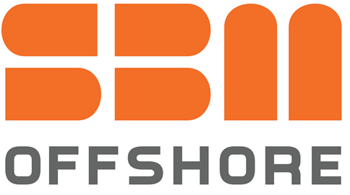
Project- Citade De Saquarema FPSO
Employer- Single Buoy Moorings (SBM)

E&I Hazardous Area Supervisor

Reported Directly to Electrical Group Safety Manager, Chinese Built FPSO having final Inspection in holding location prior to hook up.

Key Achievements/Main Duties:
- Supervising team of 12 Expat ATEX inspectors to carry out a full close inspection and programming of Arnlea handheld system RFID’s
- Liasing with local inspectors and technicians to close defects and providing technical guidance to international standards
- Maintaining work scopes for inspectors including creating work packs, providing technical assistance, raising permits and updating of Ex register to reflect actual equipment installed

June 2014- February 2016

Location- HHI Shipyard, Ulsan, South Korea | 
Project- Glen Lyon FPSO/Clair Ridge Modules
Employer- Cenelec Standards Inspections (BP)

Lead QC ATEX Inspector

Key Achievements/Main Duties:
Initially brought to project to inspect vendor inspections then promoted to overall ATEX lead for Subcontractor, Expediting 32,000 Full detailed inspections with 35 Ex inspectors.

- Working to BP specification and IEC 60079 for compliance to international standards and ATEX 94/9/EC
- Collated work packs for all inspections
- Fully conversant with GOC, Sharecat, Sharepoint and Excel
- Holding regular progress meetings, Creating reports and day to day managing of all issues raised within the ATEX division
- Engaged with MC/QC teams to assist with the definition of ATEX scope in line with project milestones
- Maintained a register of all Ex certified personnel suitable to carry out Ex inspections
- Raised Observation reports and engaged in potential corrective actions required
- Audited inspectors performance and Correctness of ITR input
- Conducted field sample surveys

March 2014- June 2014

Location- Anchorage in Singapore then Sail to west of Barrow Island, Australia | 
Project- Deepwater Millenium
Employer- Kaymas Engineering (Transocean)

Hazardous Areas Inspector

Key Achievements/Main Duties:

Sample inspection was required before vessel took new contract with Woodside to show Ex compliance in Australian Waters.
- Managed a team of 10 inspectors carrying out Ex remedials and sample inspection of vessel
- Ensured all equipment was suitable for Hazardous areas and raised defects in line with international standards
- Mixture of API, ATEX and IECEx apparatus installed. Guidance given to inspectors to ensure apparatus was suitable and any potential overhaul work required
- Provided Completed inspections and added to vessel’s database prior to audit

January 2014- March 2014

Location- Jebel Ali Free zone Dubai/ Burgan Oil Field Kuwait | 
Project- Grey Wolf 901/902 STE Land Rigs
Employer- Cenelec Standards Inspections (Grey Wolf)
Hazardous Areas Inspector

Key Achievements/Main Duties:

Ex verification was required for client and Kuwaiti regulations before project could spud. Initial verification was carried out in Dubai whilst under construction then on location in the Burgan oil Field Kuwait.
- Close/Detailed inspection of GW 901/902 land rigs in NOV Jebel Ali
- Use of PDA to upload all inspections onto central database
- Liasing with foreign nationals to complete outstanding works
- Ensuring all equipment is compliant to API standards
- Verifying and inspecting UL/ATEX equipment for conformity to client specification, API 505 and IEC 60079

August 2013- December 2013

Location- Rough Field 8A/3B, Southern Sector, UCKS | 
Project- Rough Alpha/Rough Bravo
Employer- Cenelec Standards Inspections (Centrica)

Lead QC ATEX Inspector

Key Achievements/Main Duties:
Periodic inspection on all equipment inaccessible or required scaffolding. Scope was to reduce costs and use rope access techniques.

- Close and Detailed inspections throughout 3 modules on 3B and 2 modules on 8A
- Use of PDA uploading all inspections onto central database
- Rope access inspections throughout modules
- Ensuring all equipment is compliant to BS EN 60079
June 2013- August 2013

Location- Andrew Oil Field, Northern Sector UKCS
Project- Andrew Area Development (AAD)
Employer- Woodgroup PSN (BP)

Rope Access Electrical technician/Ex Technician

Key Achievements/Main Duties:
Andrew area Development project comprised of the installation of a new module and subsea tie backs to connect the platform with the Kinnoul Oil reservoir.

- Pre-commissioning of PA/GA system
- Completing GOC ITR’s and carrying out Ex inspections
- Rope access installation and inspection
- Performing Authority status, Completing permits for work parties and carrying out tool box talks identifying hazards and controls at work site

April 2013- June 2013

Location- D Island Kazakhstan | 
Project- Kashagan Project
Employer- Bolashak (AGIP KCO)

ATEX Inspector

Key Achievements/Main Duties:
Supervision of local Inspectors and electricians was required as project was coming near to first oil and ATEX scope was behind schedule

- 100% detailed inspections on Train 1 and Train 2 modules
- Populating Ex register for all certified equipment
- Supervising and providing advice to foreign nationals whilst carrying out remedials
October 2012- April 2013

Location- Andrew Oil Field, Northern Sector UKCS
Project- Andrew Area Development (AAD)
Employer- Woodgroup PSN (BP)

Rope Access Electrical technician/Ex Technician

Key Achievements/Main Duties:
Andrew area Development project comprised of the installation of a new module and subsea tie backs to connect the platform with the Kinnoul Oil reservoir.

- Pre-commissioning of PA/GA system
- Completing GOC ITR’s and carrying out Ex inspections
- Rope access installation and inspection
- Performing Authority status, Completing permits for work parties and carrying out tool box talks identifying hazards and controls at work site
July 2012- October 2012

Location- Sembawang Shipyard Singapore/Sail to Duba Saudi Arabia
Project- Deepwater Expedition
Employer- Kaymas Engineering (Transocean)

Hazardous Areas Inspector

Key Achievements/Main Duties:
- Installation of new PA/GA system throughout Drill ship
- Ex remedial works
- Close and detailed inspection of Ex equipment
- Updating Ex register

September 2011- July 2012

Location- OGN Shipyard, Newcastle Upon Tyne | 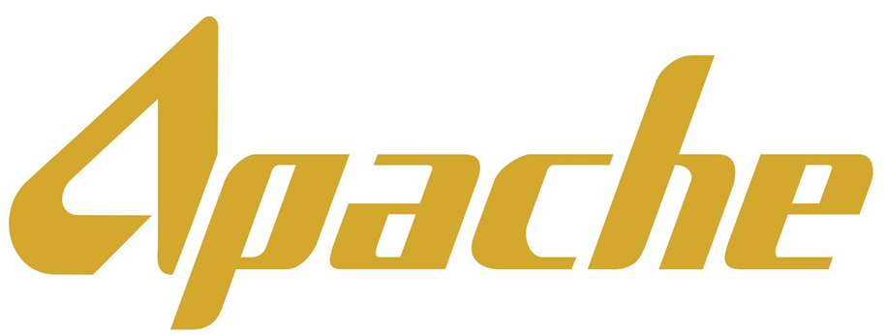
Project- Forties Alpha Satellite Project
Employer- SPIE Oil and Gas (Apache)

Hazardous Areas Inspector

Key Achievements/Main Duties:
- Installation of MV/HV switchgear
- Installation of Electrical apparatus throughout platform
- Detailed inspections of apparatus to BS EN 60079
- Appointed ATEX personnel for Tri party walk downs

May 2011- September 2011

Location- Ratcliffe Power Station | 
Project- Selective Caltalytic Reduction Project
Employer- SPIE Oil and Gas (EON)

Hazardous Areas Inspector/Electrical Technician

Key Achievements/Main Duties:
- Verification and initial detailed inspection of Ex rated equipment within a new ammonia plant
- Creating workpacks for outstanding inspections and punch list verification
- Supervising 5 inspectors to be fully conversant with BS EN 60079
April 2010- May 2011

Location- Victoria Hospital Kircaldy | 
Project- New Hospital HVAC and BMS system
Employer- Schneider Building Services

HVAC Commissioning Engineer

Key Achievements/Main Duties:
- Commissioning of Telemechanique VSD’s
- Networking all controllers using Bacnet protocol
- Maintenance and troubleshooting of pumps, VSD’s, Air handing units, motors and instrumentation
- Delegating work and providing advice to subcontractors

October 2009- April 2010

Location- Isle of Grain, Kent
Project- 3 New combined cycle gas turbines installation
Employer- SPIE Oil and Gas (EON)

Electrical Technician

Key Achievements/Main Duties:
- Various installation inside gas turbines
- Modifying panels for extra safety features within intrinsically safe circuits
- Pre-commissioning of Fire and gas system

September 2007- October 2010

Location- Newcastle upon Tyne
Project- RVI/Freeman Hospital HVAC and BMS systems
Employer- Schneider Building Services

HVAC Commissioning Engineer

Key Achievements/Main Duties

- Commissioning all plant within a new build hospital
- Designing and modifying graphics within the andover continuum database
- Completing demonstrations to client weekly of plant to be handed over and assisting in the training of NHS operatives for maintenance purposes
- Networking controllers usind Modbus protocol, Fault finding within the network and maintaining
- Maintenance and fault finding within all plant during construction and handover

REFERENCes

Mark Macgregor, QA/QC E&I lead, BP Quad 204/Clair Ridge mark.macgregor2@se1.bp.com (mark.mcgreg@yahoo.co.uk)

William Thomson : SBM Group Construction Electrical Safety Manager William.thomson@sbmoffshore.com

Brendan Cullen: Site Compliance Lead, Dana Petroleum, Western Isles Project, veng_site1@d-wif.com bcullen@me.com +447703046313

David Thompson :Kaymas Engineering Project Director: 07832126534 (dthompson@kaymas.com)

